PART 1: CODE REVIEW

1. a) Code Snippet:

<form action="feedback">

<label for="firstname"> First name : </label>

<input type="text" id="firstname" name="fname"placeholder="First Name">

<br>

<label for="lastname"> Last name : </label>

<input type="text" id="lastname" name="lname"placeholder="Last Name" >

<br>

<label for="email">Email-id : </label>

<input type="email" id="email" name="email"placeholder="Email"><br>

<p>If you have any feedback or any suggestions on the website, please fill the form below</p>

<label for="feedback">Feedback : </label>

<br>

<input type="text" id="feedback" name="feedback"placeholder="Any feedback?"><br><br>

<label for="suggestions">Suggestions :

</label>

<br>

<input type="text" id="suggestions" name="suggestions" placeholder="Suggestions"></placeholder><br><br>

<input type="submit" value="Submit">

</form>

b) Current Outcome:

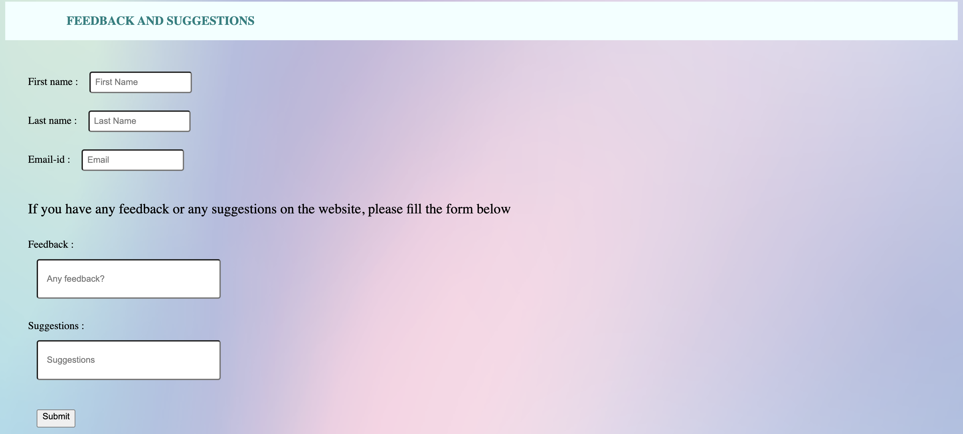

c) Desired Outcome: Using Javascript, I would want to introduce a function which will execute when submit button is pressed and which will display a notification thanking him/her for their feedback.

d) New Code Snippet:

HTML

<form id="form" >

<label for="firstname"> First name : </label>

<input type="text" id="firstname" name="firstname"placeholder="First Name">

<br>

<label for="lastname"> Last name : </label>

<input type="text" id="lastname" name="lastname"placeholder="Last Name" >

<br>

<label for="email">Email-id : </label>

<input type="email" id="email" name="email"placeholder="Email"><br>

<p>If you have any feedback or any suggestions on the website, please fill the form below</p>

<label for="feedback">Feedback : </label>

<br>

<input type="text" id="feedback" name="feedback"placeholder="Any feedback?"><br><br>

<label for="suggestions">Suggestions :

</label>

<br>

<input type="text" id="suggestions" name="suggestions" placeholder="Suggestions"></placeholder><br><br>

<input onclick="formSubmit()" type="submit" value="Submit">

</form>

Javascript:

function formSubmit(){

alert("Thank you for your Feedback!");

}

document.getElementById("Form").addEventListener("click", function(event)

{event.preventDefault()});

e) The new outcome

1. a) Code Snippet: